Day 4 – Marketing to government agencies

If you participated in yesterday’s HW assignment than you know which agencies buy your service.

This is a crucial first step in working with agencies as a prime, subcontractor or consultant to other firms. This information will be helpful for today’s lesson.

Now that we know who (which agencies) have what we want, let’s determine where are the upcoming contract opportunities for those specific needs.

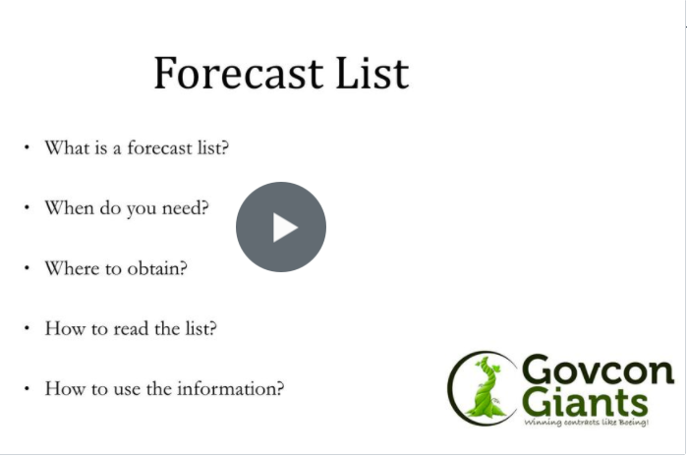

Find who’s got your money now

FYI: Tomorrow is the first day that we will learn the Strategy 1 of 4 that I’ve used for winning federal contracts.

Eric Coffie

